28.46: The magnetic field of charge 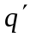 at the location of charge q is into the page.
where is the angle between 